**Bài toán cái túi bằng phương pháp quy hoạch động**

1. Nêu bài toán

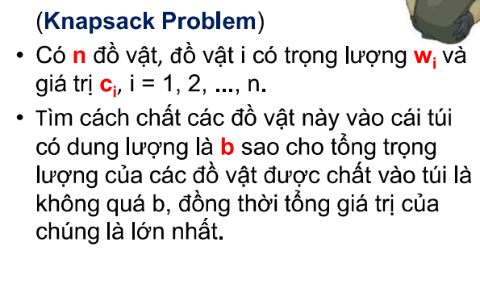

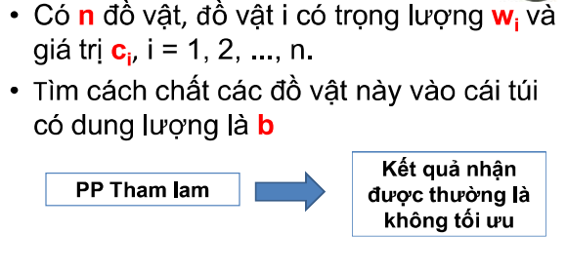

2.Mô tả chi tiết thuật toán

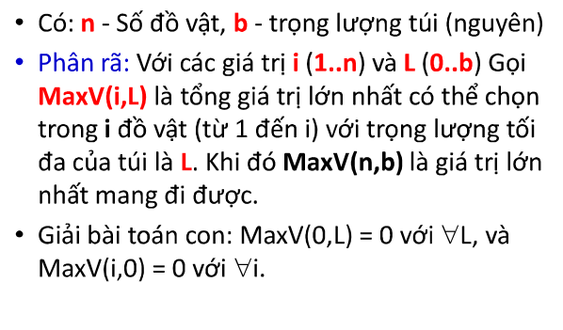

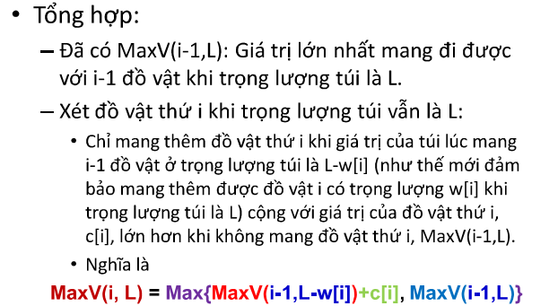

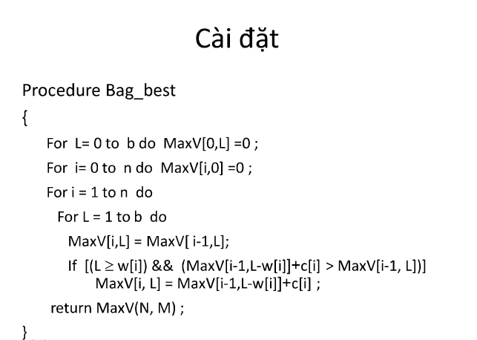

3.Bộ dữ liệu

1. Bộ thứ nhất

|  |  |
| --- | --- |
| 6 19  3 7  4 10  5 20  7 19  6 13  9 40 | Cac phan tu duoc chon la: 2 3 6  Tong khoi luong la: 18  Tong gia tri la: 70 |

|  |  |  |  |  |  |  |  |  |  |  |  |  |  |  |  |  |  |  |  |  |  |  |
| --- | --- | --- | --- | --- | --- | --- | --- | --- | --- | --- | --- | --- | --- | --- | --- | --- | --- | --- | --- | --- | --- | --- |
|  |  | i/L | 0 | 1 | 2 | 3 | 4 | 5 | 6 | 7 | 8 | 9 | 10 | 11 | 12 | 13 | 14 | 15 | 16 | 17 | 18 | 19 |
| **c** | **w** | 0 | 0 | 0 | 0 | 0 | 0 | 0 | 0 | 0 | 0 | 0 | 0 | 0 | 0 | 0 | 0 | 0 | 0 | 0 | 0 | 0 |
| **7** | **3** | 1 | 0 | 0 | 0 | 7 | 7 | 7 | 7 | 7 | 7 | 7 | 7 | 7 | 7 | 7 | 7 | 7 | 7 | 7 | 7 | 7 |
| **10** | **4** | 2 | 0 |  |  |  |  |  |  |  |  |  |  |  |  |  |  |  |  |  |  |  |
| **20** | **5** | 3 | 0 |  |  |  |  |  |  |  |  |  |  |  |  |  |  |  |  |  |  |  |
| **19** | **7** | 4 | 0 |  |  |  |  |  |  |  |  |  |  |  |  |  |  |  |  |  |  |  |
| **13** | **6** | 5 | 0 |  |  |  |  |  |  |  |  |  |  |  |  |  |  |  |  |  |  |  |
| **40** | **9** | 6 | 0 |  |  |  |  |  |  |  |  |  |  |  |  |  |  |  |  |  |  |  |

|  |  |  |  |  |  |  |  |  |  |  |  |  |  |  |  |  |  |  |  |  |  |  |
| --- | --- | --- | --- | --- | --- | --- | --- | --- | --- | --- | --- | --- | --- | --- | --- | --- | --- | --- | --- | --- | --- | --- |
|  |  | i/L | 0 | 1 | 2 | 3 | 4 | 5 | 6 | 7 | 8 | 9 | 10 | 11 | 12 | 13 | 14 | 15 | 16 | 17 | 18 | 19 |
| **c** | **w** | 0 | 0 | 0 | 0 | 0 | 0 | 0 | 0 | 0 | 0 | 0 | 0 | 0 | 0 | 0 | 0 | 0 | 0 | 0 | 0 | 0 |
| **7** | **3** | 1 | 0 | 0 | 0 | 7 | 7 | 7 | 7 | 7 | 7 | 7 | 7 | 7 | 7 | 7 | 7 | 7 | 7 | 7 | 7 | 7 |
| **10** | **4** | 2 | 0 | 0 | 0 | 7 | 10 | 10 | 10 | 17 | 17 | 17 | 17 | 17 | 17 | 17 | 17 | 17 | 17 | 17 | 17 | 17 |
| **20** | **5** | 3 | 0 |  |  |  |  |  |  |  |  |  |  |  |  |  |  |  |  |  |  |  |
| **19** | **7** | 4 | 0 |  |  |  |  |  |  |  |  |  |  |  |  |  |  |  |  |  |  |  |
| **13** | **6** | 5 | 0 |  |  |  |  |  |  |  |  |  |  |  |  |  |  |  |  |  |  |  |
| **40** | **9** | 6 | 0 |  |  |  |  |  |  |  |  |  |  |  |  |  |  |  |  |  |  |  |

|  |  |  |  |  |  |  |  |  |  |  |  |  |  |  |  |  |  |  |  |  |  |  |
| --- | --- | --- | --- | --- | --- | --- | --- | --- | --- | --- | --- | --- | --- | --- | --- | --- | --- | --- | --- | --- | --- | --- |
|  |  | i/L | 0 | 1 | 2 | 3 | 4 | 5 | 6 | 7 | 8 | 9 | 10 | 11 | 12 | 13 | 14 | 15 | 16 | 17 | 18 | 19 |
| **c** | **w** | 0 | 0 | 0 | 0 | 0 | 0 | 0 | 0 | 0 | 0 | 0 | 0 | 0 | 0 | 0 | 0 | 0 | 0 | 0 | 0 | 0 |
| **7** | **3** | 1 | 0 | 0 | 0 | 7 | 7 | 7 | 7 | 7 | 7 | 7 | 7 | 7 | 7 | 7 | 7 | 7 | 7 | 7 | 7 | 7 |
| **10** | **4** | 2 | 0 | 0 | 0 | 7 | 10 | 10 | 10 | 17 | 17 | 17 | 17 | 17 | 17 | 17 | 17 | 17 | 17 | 17 | 17 | 17 |
| **20** | **5** | 3 | 0 | 0 | 0 | 7 | 10 | 20 | 20 | 20 | 27 | 30 | 30 | 30 | 37 | 37 | 37 | 37 | 37 | 37 | 37 | 37 |
| **19** | **7** | 4 | 0 |  |  |  |  |  |  |  |  |  |  |  |  |  |  |  |  |  |  |  |
| **13** | **6** | 5 | 0 |  |  |  |  |  |  |  |  |  |  |  |  |  |  |  |  |  |  |  |
| **40** | **9** | 6 | 0 |  |  |  |  |  |  |  |  |  |  |  |  |  |  |  |  |  |  |  |

|  |  |  |  |  |  |  |  |  |  |  |  |  |  |  |  |  |  |  |  |  |  |  |
| --- | --- | --- | --- | --- | --- | --- | --- | --- | --- | --- | --- | --- | --- | --- | --- | --- | --- | --- | --- | --- | --- | --- |
|  |  | i/L | 0 | 1 | 2 | 3 | 4 | 5 | 6 | 7 | 8 | 9 | 10 | 11 | 12 | 13 | 14 | 15 | 16 | 17 | 18 | 19 |
| **c** | **w** | 0 | 0 | 0 | 0 | 0 | 0 | 0 | 0 | 0 | 0 | 0 | 0 | 0 | 0 | 0 | 0 | 0 | 0 | 0 | 0 | 0 |
| **7** | **3** | 1 | 0 | 0 | 0 | 7 | 7 | 7 | 7 | 7 | 7 | 7 | 7 | 7 | 7 | 7 | 7 | 7 | 7 | 7 | 7 | 7 |
| **10** | **4** | 2 | 0 | 0 | 0 | 7 | 10 | 10 | 10 | 17 | 17 | 17 | 17 | 17 | 17 | 17 | 17 | 17 | 17 | 17 | 17 | 17 |
| **20** | **5** | 3 | 0 | 0 | 0 | 7 | 10 | 20 | 20 | 20 | 27 | 30 | 30 | 30 | 37 | 37 | 37 | 37 | 37 | 37 | 37 | 37 |
| **19** | **7** | 4 | 0 | 0 | 0 | 7 | 10 | 20 | 20 | 20 | 27 | 30 | 30 | 30 | 39 | 39 | 39 | 46 | 49 | 49 | 49 | 56 |
| **13** | **6** | 5 | 0 |  |  |  |  |  |  |  |  |  |  |  |  |  |  |  |  |  |  |  |
| **40** | **9** | 6 | 0 |  |  |  |  |  |  |  |  |  |  |  |  |  |  |  |  |  |  |  |

|  |  |  |  |  |  |  |  |  |  |  |  |  |  |  |  |  |  |  |  |  |  |  |
| --- | --- | --- | --- | --- | --- | --- | --- | --- | --- | --- | --- | --- | --- | --- | --- | --- | --- | --- | --- | --- | --- | --- |
|  |  | i/L | 0 | 1 | 2 | 3 | 4 | 5 | 6 | 7 | 8 | 9 | 10 | 11 | 12 | 13 | 14 | 15 | 16 | 17 | 18 | 19 |
| **c** | **w** | 0 | 0 | 0 | 0 | 0 | 0 | 0 | 0 | 0 | 0 | 0 | 0 | 0 | 0 | 0 | 0 | 0 | 0 | 0 | 0 | 0 |
| **7** | **3** | 1 | 0 | 0 | 0 | 7 | 7 | 7 | 7 | 7 | 7 | 7 | 7 | 7 | 7 | 7 | 7 | 7 | 7 | 7 | 7 | 7 |
| **10** | **4** | 2 | 0 | 0 | 0 | 7 | 10 | 10 | 10 | 17 | 17 | 17 | 17 | 17 | 17 | 17 | 17 | 17 | 17 | 17 | 17 | 17 |
| **20** | **5** | 3 | 0 | 0 | 0 | 7 | 10 | 20 | 20 | 20 | 27 | 30 | 30 | 30 | 37 | 37 | 37 | 37 | 37 | 37 | 37 | 37 |
| **19** | **7** | 4 | 0 | 0 | 0 | 7 | 10 | 20 | 20 | 20 | 27 | 30 | 30 | 30 | 39 | 39 | 39 | 46 | 49 | 49 | 49 | 56 |
| **13** | **6** | 5 | 0 | 0 | 0 | 7 | 10 | 20 | 20 | 20 | 27 | 30 | 30 | 33 | 39 | 39 | 40 | 46 | 49 | 49 | 52 | 56 |
| **40** | **9** | 6 | 0 |  |  |  |  |  |  |  |  |  |  |  |  |  |  |  |  |  |  |  |

|  |  |  |  |  |  |  |  |  |  |  |  |  |  |  |  |  |  |  |  |  |  |  |
| --- | --- | --- | --- | --- | --- | --- | --- | --- | --- | --- | --- | --- | --- | --- | --- | --- | --- | --- | --- | --- | --- | --- |
|  |  | i/L | 0 | 1 | 2 | 3 | 4 | 5 | 6 | 7 | 8 | 9 | 10 | 11 | 12 | 13 | 14 | 15 | 16 | 17 | 18 | 19 |
| **c** | **w** | 0 | 0 | 0 | 0 | 0 | 0 | 0 | 0 | 0 | 0 | 0 | 0 | 0 | 0 | 0 | 0 | 0 | 0 | 0 | 0 | 0 |
| **7** | **3** | 1 | 0 | 0 | 0 | 7 | 7 | 7 | 7 | 7 | 7 | 7 | 7 | 7 | 7 | 7 | 7 | 7 | 7 | 7 | 7 | 7 |
| **10** | **4** | 2 | 0 | 0 | 0 | 7 | 10 | 10 | 10 | 17 | 17 | 17 | 17 | 17 | 17 | 17 | 17 | 17 | 17 | 17 | 17 | 17 |
| **20** | **5** | 3 | 0 | 0 | 0 | 7 | 10 | 20 | 20 | 20 | 27 | 30 | 30 | 30 | 37 | 37 | 37 | 37 | 37 | 37 | 37 | 37 |
| **19** | **7** | 4 | 0 | 0 | 0 | 7 | 10 | 20 | 20 | 20 | 27 | 30 | 30 | 30 | 39 | 39 | 39 | 46 | 49 | 49 | 49 | 56 |
| **13** | **6** | 5 | 0 | 0 | 0 | 7 | 10 | 20 | 20 | 20 | 27 | 30 | 30 | 33 | 39 | 39 | 40 | 46 | 49 | 49 | 52 | 56 |
| **40** | **9** | 6 | 0 | 0 | 0 | 7 | 10 | 20 | 20 | 20 | 27 | 40 | 40 | 40 | 40 | 50 | 60 | 60 | 60 | 67 | 70 | 70 |

1. Bộ thứ hai

n=10, b= 25

mi: 3 4 5 7 6 9 3 4 5 6

ci: 7 10 20 19 13 40 23 21 12 13

* Kết quả in ra:

Gia tri lon nhat cua tui: 114

Chon vat thu 8 Khoi luong : 4 Gia tri: 21

Chon vat thu 7 Khoi luong : 3 Gia tri: 23

Chon vat thu 6 Khoi luong : 9 Gia tri: 40

Chon vat thu 3 Khoi luong : 5 Gia tri: 20

Chon vat thu 2 Khoi luong : 4 Gia tri: 10

1. Bộ thứ ba

n=10, b=20

mi: 3 4 5 7 6 9 1 2 3 2

ci: 7 10 20 19 13 40 12 12 13 14

-Kết quả in ra :

Gia tri lon nhat cua tui: 99

Chon vat thu 10, Khoi luong : 2 ,Gia tri: 14

Chon vat thu 9, Khoi luong : 3, Gia tri: 13

Chon vat thu 7 ,Khoi luong : 1 ,Gia tri: 12

Chon vat thu 6 ,Khoi luong : 9 ,Gia tri: 40

Chon vat thu 3, Khoi luong : 5 ,Gia tri: 20

1. Bộ dữ liệu 4

N=10,b= 30

mi= 3 4 5 7 6 9 9 12 11 10

ci= 7 10 20 19 13 40 12 13 14 15

Gia tri lon nhat cua tui: 99

Chon vat thu 6 Khoi luong : 9 Gia tri: 40

Chon vat thu 5 Khoi luong : 6 Gia tri: 13

Chon vat thu 4 Khoi luong : 7 Gia tri: 19

Chon vat thu 3 Khoi luong : 5 Gia tri: 20

Chon vat thu 1 Khoi luong : 3 Gia tri: 7

1. Bộ dữ liệu 5

n=10,b= 25

mi: 3 4 5 7 6 9 1 2 3 4

ci: 7 10 20 19 13 40 4 5 6 7

-Kết quả in ra:

Gia tri lon nhat cua tui: 90

Chon vat thu 7 Khoi luong : 1 Gia tri: 4

Chon vat thu 6 Khoi luong : 9 Gia tri: 40

Chon vat thu 4 Khoi luong : 7 Gia tri: 19

Chon vat thu 3 Khoi luong : 5 Gia tri: 20

Chon vat thu 1 Khoi luong : 3 Gia tri: 7

1. Chương trình Dev C++
2. Đánh giá độ phức tạp
3. Chương trình Dev C++
4. Đánh giá độ phức tạp